|  |  |
| --- | --- |
|  | **DEPARTMENT OF COMPUTER ENGINEERING** |

**Mini Project Report**

|  |  |
| --- | --- |
| Semester | S.E. Semester IV – Computer Engineering |
| Subject | Skill Base Lab Course: Python Programming (CSL405) |
| Subject Professor In-charge | Prof. Swapnil S. Sonawane |
| Assisting Teachers | Prof. Swapnil S. Sonawane |

|  |  |
| --- | --- |
| Roll Numbers | Name of Students |
| 20102A0003 | Vinay Bhojwani |
| 20102A0037 | Snehal Lohar |
| 20102B0043 | Nandini Gore |
| 20102A0067 | Sameer Shaikh |

**Name of the Project:**

RythmicChillz: Music Player

**Project Description:**

**INTRODUCTION**:

🡪 In our daily life, we see every person has a hobby and that is listening to music. So, in order to listen to music, they all need a Music player (hardware or software) where they can play their favorite songs. And we have to install this music player on our computer, based on the Operating system i.e., Windows, Macintosh, Android, Linux, etc. Then we can listen to our favorite songs.

🡪 ***Problem Statement:*** To create a music player having two options i.e., music as well as podcasts. Here, the user would be required to create an account on this app, only after which he/she can login into the app. He/she can either listen to a music or a podcast (with different categories).

**Note: -** These music/podcasts can be played on his/her m/c iff these files are pe-downloaded on his/her m/c(s) respectively.

**Libraries used for Music Player Project:**

1. **Tkinter:**

🡪 The Tkinter library is most popular and very easy to use and it comes with many widgets (these widgets help in the creation of nice-looking GUI Applications). Also, Tkinter is a very light-weight module and it is helpful in creating cross-platform applications (so the same code can easily work on **Windows**, **macOS**, and **Linux).**

1. **Pygame:**

🡪 Pygame is a Python module that works with computer graphics and sound libraries and is designed with the power of playing with different multimedia formats like audio, video, etc. While creating our Music Player application, we will be using Pygame's mixer.music module for providing different functionality to our music player application that is usually related to the manipulation of the song tracks.

1. **OS**:

🡪 There is no need to install this module explicitly, as it comes with the standard library of Python. This module provides different functions for interaction with the Operating System. In this tutorial, we are going to use the OS module for **fetching the playlist of songs from the specified directory** and make it available to the music player application.

🡪Thus, we have successfully created python mp3 music player, now we don’t have to rely on any other app.

🡪 Through this python project we learned a lot of things about python and its libraries, the first one being the Tkinter library, a widely-used GUI library and various widgets that it offers, then the important mixer module of the Pygame library which is used to manipulate the music.

**Project Code:**

1. **Login Page:**

from email import message

from tkinter import *

from MySQLdb import *

from tkinter import messagebox

login1=Tk()

login1.title("Login_Screen")

login1.geometry("1199x600+100+50")

#-----BG Image------

bg=PhotoImage(file="C:\\Users\\Vinay Bhojwani\\AppData\\Local\\Programs\\Python\\Python39\\SBL_MiniProject\\Images\\bg.png")

bg_image=Label(login1,image=bg).place(x=0,y=0,relwidth=1,relheight=1)

#----Login Frame----

frame_login=Frame(login1,bg="white")

frame_login.place(x=350,y=40,height=327,width=500)

title=Label(frame_login,text="Login Here",font='Impact 35 bold',fg="#3B4B64",bg="white").place(x=130,y=20)

label=Label(frame_login,text="Don't have account?",font=("Goudy old style",15,"bold"),fg="#d25d17",bg="white").place(x=110,y=75)

lbl_user=Label(frame_login,text="Username",font=("Goudy old style",15,"bold"),fg="#3B4B64",bg="white").place(x=60,y=110)

txt_user=Entry(frame_login,font=("times new roman",15),bg="lightgray")

txt_user.place(x=70,y=140,width=350,height=35)

lbl_pass=Label(frame_login,text="Password",font=("Goudy old style",15,"bold"),fg="#3B4B64",bg="white").place(x=60,y=190)

txt_pass=Entry(frame_login,font=("times new roman",15),bg="lightgray")

txt_pass.config(show='*')

txt_pass.place(x=70,y=220,width=350,height=35)

def eye1():

    txt_pass.config(show='')

eye=PhotoImage(file="C:\\Users\\Vinay Bhojwani\\AppData\\Local\\Programs\\Python\\Python39\\SBL_MiniProject\\Images\\view.png")

b=Button(frame_login,image=eye,command=eye1,bd=0,bg='white').place(x=440,y=210)

#Checking Credentials

def check():

    c=connect('localhost','root','Bappamorya@1133','sbl_mp')

    mycursor=c.cursor()

    uname=txt_user.get()

    pas=txt_pass.get()

    sql='select * from signup where Username = %s and Password = %s'

    mycursor.execute(sql,[uname,pas])

    row=mycursor.fetchall()

    if  uname=='' and pas=='':

        messagebox.showwarning("Warning","Kindly enter all the fields")

    elif row:

        messagebox.showinfo("Congratulations","Login Successful!")

        login1.destroy()

        import loadingPage

    elif uname=='' or pas=='':

        messagebox.showwarning("Warning","Kindly enter all the fields")

    else:

        messagebox.showerror("Error","Invalid Username or Password")

    c.commit()

c.close()

#Forgot Password Window

def forgotpass():

    login1.destroy()

    fpass=Tk()

    fpass.title("Forgot Passoword")

    fpass.geometry("1199x600+100+50")

    #-----BG Image------

    bg=PhotoImage(file="C:\\Users\\Vinay Bhojwani\\AppData\\Local\\Programs\\Python\\Python39\\SBL_MiniProject\\Images\\bg.png")

    bg_image=Label(fpass,image=bg).place(x=0,y=0,relwidth=1,relheight=1)

    #----Login Frame----

    frame_fpass=Frame(fpass,bg="white")

    frame_fpass.place(x=350,y=40,height=327,width=500)

    title=Label(frame_fpass,text="New Credentials",font='Impact 35 bold',fg="#3B4B64",bg="white").place(x=120,y=20)

    desc=Label(frame_fpass,text="Enter new credentials here",font=("Goudy old style",15,"bold"),fg="#d25d17",bg="white").place(x=150,y=80)

    lbl_user1=Label(frame_fpass,text="Your Username",font=("Goudy old style",15,"bold"),fg="#3B4B64",bg="white").place(x=60,y=110)

    txt_user1=Entry(frame_fpass,font=("times new roman",15),bg="lightgray")

    txt_user1.place(x=70,y=140,width=350,height=35)

    lbl_pass1=Label(frame_fpass,text="New Password",font=("Goudy old style",15,"bold"),fg="#3B4B64",bg="white").place(x=60,y=190)

    txt_pass1=Entry(frame_fpass,font=("times new roman",15),bg="lightgray")

    txt_pass1.config(show='*')

    txt_pass1.place(x=70,y=220,width=350,height=35)

    #Updatig credentials

    def newcred():

        c=connect('localhost','root','Bappamorya@1133','sbl_mp')

        mycursor=c.cursor()

        uname=txt_user1.get()

        query="select * from signup where Username=%s"

        mycursor.execute(query,[uname])

        result=mycursor.fetchall()

        if not result:

            messagebox.showerror("Error","User doesn't exist...")

        else:

            messagebox.showinfo("Info","User verified...")

            npas=txt_pass1.get()

            if npas=='':

                messagebox.showerror("Error","Please enter password...")

            else:

                sql="update signup set Password=%s where Username=%s"

                mycursor.execute(sql,[npas,uname])

                messagebox.showinfo("Success","Password Ressetted...")

                messagebox.showinfo("Info","Let's Login...")

                fpass.destroy()

                import Login

        c.commit()

        c.close()

    submit_btn=Button(fpass,text="Submit",fg="White",bg="#d77337",font=("times new roman",20,"bold"),command=newcred).place(x=530,y=320,width=180,height=40)

    fpass.mainloop()

forgotpass=Button(frame_login,text="Forgot Password?",bg="white",fg="#d77337",bd=0,font=("times new roman",12,'italic'),command=forgotpass).place(x=55,y=260)

def signup_window():

    login1.destroy()

    import SignUp

signup_btn=Button(frame_login,text="Sign in",command=signup_window,font=("Goudy old style",15,"bold"),bd=0,fg="#3B4B64",bg="white").place(x=280,y=72)

login_btn=Button(login1,text="Login",fg="White",bg="#d77337",font=("times new roman",20,"bold"),command=check).place(x=510,y=340,width=180,height=40)

login1.mainloop()

1. **Sign Up Page:**

from tkinter import *

from email import message

from MySQLdb import *

from tkinter import messagebox

signup=Tk()

signup.title("Signup Screen")

signup.geometry("1199x600+100+50")

#-----BG Image------

bg=PhotoImage(file="C:\\Users\\Vinay Bhojwani\\AppData\\Local\\Programs\\Python\\Python39\\SBL_MiniProject\\Images\\bg.png")

bg_image=Label(signup,image=bg).place(x=0,y=0,relwidth=1,relheight=1)

#----signup Frame----

frame_signup=Frame(signup,bg="white")

frame_signup.place(x=350,y=20,height=370,width=500)

title=Label(frame_signup,text="Sign Up",font=("Impact",35,"bold"),fg="#3B4B64",bg="white").place(x=170,y=5)

label=Label(frame_signup,text="Already have an account?",font=("Goudy old style",15,"bold"),fg="#d25d17",bg="white").place(x=90,y=70)

lbl_user=Label(frame_signup,text="Username",font=("Goudy old style",15,"bold"),fg="#3B4B64",bg="white").place(x=60,y=100)

txt_user=Entry(frame_signup,font=("times new roman",15),bg="lightgray")

txt_user.place(x=70,y=130,width=350,height=35)

lbl_pass=Label(frame_signup,text="Password",font=("Goudy old style",15,"bold"),fg="#3B4B64",bg="white").place(x=60,y=180)

txt_pass=Entry(frame_signup,font=("times new roman",15),bg="lightgray")

txt_pass.config(show='*')

txt_pass.place(x=70,y=210,width=350,height=35)

lbl_name=Label(frame_signup,text="Enter your Name",font=("Goudy old style",15,"bold"),fg="#d25d17",bg="white").place(x=60,y=260)

txt_name=Entry(frame_signup,font=("times new roman",15),bg="#3B4B64",fg="white")

txt_name.place(x=70,y=290,width=350,height=35)

def eye1():

    txt_pass.config(show='')

eye=PhotoImage(file="C:\\Users\\Vinay Bhojwani\\AppData\\Local\\Programs\\Python\\Python39\\SBL_MiniProject\\Images\\view.png")

b=Button(frame_signup,image=eye,command=eye1,bd=0,bg='white').place(x=440,y=200)

#Checking Credentials

def add():

    c=connect('localhost','root','Bappamorya@1133','sbl_mp')

    mycursor=c.cursor()

    uname=txt_user.get()

    pas=txt_pass.get()

    name=txt_name.get()

    sql='insert into signup VALUES (%s,%s,%s)'

    mycursor.execute(sql,[uname,pas,name])

    messagebox.showinfo("Welcome","You are successfully signed in!!")

    c.commit()

    c.close()

    messagebox.showinfo("Info","Let's Login...")

    signup.destroy()

    import Login

#forget=Button(frame_signup,text="Forget Password?",bg="white",fg="#d77337",bd=0,font=("times new roman",12)).place(x=60,y=260)

signup_btn=Button(signup,text="Sign Up",fg="White",bg="#d77337",font=("times new roman",20,"bold"),command=add).place(x=510,y=370,width=180,height=40)

def loginn_window():

    signup.destroy()

    import Login

signin_btn=Button(frame_signup,text="Sign in",command=loginn_window,font=("Goudy old style",15,"bold"),bd=0,fg="#3B4B64",bg="white").place(x=310,y=67)

signup.mainloop()

1. **Loading Page:**

from tkinter import ttk

from tkinter.ttk import Progressbar

from tkinter import *

w=Tk()

width_of_window = 427

height_of_window = 250

screen_width = w.winfo_screenwidth()

screen_height = w.winfo_screenheight()

x_coordinate = (screen_width/2)-(width_of_window/2)

y_coordinate = (screen_height/2)-(height_of_window/2)

w.geometry("%dx%d+%d+%d" %(width_of_window,height_of_window,x_coordinate,y_coordinate))

w.overrideredirect(1)

s = ttk.Style()

s.theme_use('clam')

s.configure("red.Horizontal.TProgressbar", foreground='red', background='#D77337')

progress=Progressbar(w,style="red.Horizontal.TProgressbar",orient=HORIZONTAL,length=500,mode='determinate',)

def bar():

    l4=Label(w,text='Loading...',fg='white',bg=a)

    lst4=('Calibri (Body)',10)

    l4.config(font=lst4)

    l4.place(x=18,y=210)

    import time

    r=0

    for i in range(100):

        progress['value']=r

        w.update_idletasks()

        time.sleep(0.04)

        r=r+1

    w.destroy()

    import Welcome

progress.place(x=-10,y=235)

'''

def rgb(r):

    return "#%02x%02x%02x" % r

#Frame(w,width=432,height=241,bg=rgb((100,100,100))).

'''

a='#29374B'

Frame(w,width=427,height=241,bg=a).place(x=0,y=0)  #249794

b1=Button(w,width=10,height=1,text='Get Started',font=('Calibiri',12),command=bar,border=0,fg='#D77337',bg='white')

b1.place(x=170,y=200)

######## Label #########

l1=Label(w,text='Rythmic Chillz',fg='white',bg=a)

lst1=('Calibri (Body)',18,'bold')

l1.config(font=lst1)

l1.place(x=50,y=80)

# l2=Label(w,text='Welcomes',fg='white',bg=a)

# lst2=('Calibri (Body)',18)

# l2.config(font=lst2)

# l2.place(x=155,y=82)

l3=Label(w,text='WelcomesYou!',fg='white',bg=a)

lst3=('Calibri (Body)',13)

l3.config(font=lst3)

l3.place(x=50,y=110)

w.mainloop()

1. **Welcome Page:**

from tkinter import *

from email import message

# from MySQLdb import *

from tkinter import messagebox

welcome=Tk()

welcome.title("Welcome Screen")

welcome.geometry("1199x600+100+50")

#-----BG Image------

bg=PhotoImage(file="C:\\Users\\Vinay Bhojwani\\AppData\\Local\\Programs\\Python\\Python39\\SBL_MiniProject\\Images\\Welcome_final.png")

bg_image=Label(welcome,image=bg).place(x=0,y=0,relwidth=1,relheight=1)

label=Label(welcome,text="Welcome to RhythmicChillz!",font=("Impact",35),fg="#d77337",bg="#3B4B64").place(x=90,y=70)

#-----Buttons--------

def music():

    welcome.destroy()

    import MusicPlayer

def podcast():

   welcome.destroy()

   import Podcast

btn_music=Button(welcome,text="Music",bg="#d77337",fg="white",font=("times new roman",20,"bold"),command=music).place(x=750,y=240,width=180,height=40)

btn_podcast=Button(welcome,text="Podcast",bg="#d77337",fg="white",font=("times new roman",20,"bold"),command=podcast).place(x=750,y=300,width=180,height=40)

welcome.mainloop()

1. **Music:**

from tkinter import *

import tkinter as tk

from tkinter import ttk, filedialog

from pygame import mixer

import os

root=Tk()

root.title("Music Player")

root.geometry("1199x600+100+50")

bg=PhotoImage(file="C:\\Users\\Vinay Bhojwani\\AppData\\Local\\Programs\\Python\\Python39\\SBL_MiniProject\\Images\\Music_Final.png")

bg_image=Label(root,image=bg).place(x=0,y=0,relwidth=1,relheight=1)

root.resizable(False,False)

mixer.init()

def open_folder():

    path=filedialog.askdirectory()

    if path:

        os.chdir(path)

        songs=os.listdir(path)

        for song in songs:

            if song.endswith(".mp3"):

                playlist.insert(END,song)

def play_song():

    music_name=playlist.get(ACTIVE)

    mixer.music.load(playlist.get(ACTIVE))

    mixer.music.play()

    music.config(text=music_name[0:-4])

#icon

image_icon=PhotoImage(file="C:\\Users\\Vinay Bhojwani\\AppData\\Local\\Programs\\Python\\Python39\\SBL_MiniProject\\Images\\logo.png")

root.iconphoto(False,image_icon)

#=PhotoImage(file="C:\\Users\\Snehal\\Downloads\\Python mini project\\images\\top.png")

#Label(root,image=Top, bg="#0f1a2b").pack()

#Logo

#Logo=PhotoImage(file="C:\\Users\\Snehal\\Downloads\\Python mini project\\images\\logo.png")

#Label(root,image=Logo, bg="#0f1a2b").place(x=65,y=115)

#Label

btn_container=Label(root,text="",font=("times new roman",15),fg="white",bg="Black",bd=2).place(x=250,y=180,width=300,height=250)

#button

play_button=PhotoImage(file="C:\\Users\\Vinay Bhojwani\\AppData\\Local\\Programs\\Python\\Python39\\SBL_MiniProject\\Images\\play.png")

Button(root,image=play_button,bg="black",bd=0,command=play_song).place(x=350,y=200)

stop_button=PhotoImage(file="C:\\Users\\Vinay Bhojwani\\AppData\\Local\\Programs\\Python\\Python39\\SBL_MiniProject\\Images\\stop.png")

Button(root,image=stop_button,bg="black",bd=0,command=mixer.music.stop).place(x=280,y=300)

resume_button=PhotoImage(file="C:\\Users\\Vinay Bhojwani\\AppData\\Local\\Programs\\Python\\Python39\\SBL_MiniProject\\Images\\resume.png")

Button(root,image=resume_button,bg="black",bd=0,command=mixer.music.unpause).place(x=365,y=300)

pause_button=PhotoImage(file="C:\\Users\\Vinay Bhojwani\\AppData\\Local\\Programs\\Python\\Python39\\SBL_MiniProject\\Images\\pause.png")

Button(root,image=pause_button,bg="black",bd=0,command=mixer.music.pause).place(x=450,y=300)

#label

music=Label(root,text="",font=("arial",15),fg="white",bg="#7C8EAD")

music.place(x=382,y=450,anchor="center")

#music

Menu=PhotoImage(file="C:\\Users\\Vinay Bhojwani\\AppData\\Local\\Programs\\Python\\Python39\\SBL_MiniProject\\Images\\menu.png")

Label(root,image=Menu,bg="#29374B").pack(padx=10,pady=50,side=RIGHT)

music_frame= Frame(root,bd=2,relief=RIDGE)

music_frame.place(x=615,y=205,width=560,height=250)

Button(root,text="Open Folder",width=15,height=2,font=("Sans Serif",12,"bold"),fg="white",bg="#D77337",command=open_folder).place(x=620,y=135)

scroll = Scrollbar(music_frame)

playlist=Listbox(music_frame,width=100,font=("Sans Serif",15),bg="#29374B",fg="white",selectbackground="#7C8EAD",cursor="hand2",bd=0,yscrollcommand=scroll.set)

scroll.config(command=playlist.yview)

scroll.pack(side=RIGHT,fill=Y)

playlist.pack(side=LEFT,fill=BOTH)

def wlcm_window():

    root.destroy()

    import Welcome

Back=PhotoImage(file="C:\\Users\\Vinay Bhojwani\\AppData\\Local\\Programs\\Python\\Python39\\SBL_MiniProject\\Images\\previous.png")

back_btn=Button(root,image=Back,fg="white",bg="#29374B",bd=0,command=wlcm_window).place(x=60,y=450)

root.mainloop()

1. **Podcast’s Category:**

from tkinter import *

Podcast=Tk()

Podcast.geometry("1199x600")

Podcast.title("Podcast")

bg=PhotoImage(file="C:\\Users\\Vinay Bhojwani\\AppData\\Local\\Programs\\Python\\Python39\\SBL_MiniProject\\Images\\Podcast resize.png")

bg_image=Label(Podcast,image=bg).place(x=0,y=0)

photo1 = PhotoImage(file = "C:\\Users\\Vinay Bhojwani\\AppData\\Local\\Programs\\Python\\Python39\\SBL_MiniProject\\Images\\R&S B.png")

btn=Button(Podcast, image = photo1, bd=0).place(x=51,y=169)

def sm_window():

    Podcast.destroy()

    import Podcast_SM

photo2 = PhotoImage(file = "C:\\Users\\Vinay Bhojwani\\AppData\\Local\\Programs\\Python\\Python39\\SBL_MiniProject\\Images\\SM B.png")

btn=Button(Podcast, image = photo2, bd=0,command=sm_window).place(x=51,y=309)

photo3 = PhotoImage(file = "C:\\Users\\Vinay Bhojwani\\AppData\\Local\\Programs\\Python\\Python39\\SBL_MiniProject\\Images\\H B.png")

btn=Button(Podcast, image = photo3, bd=0).place(x=51,y=460)

def suc_window():

    Podcast.destroy()

    import Podcast_SC

photo4 = PhotoImage(file = "C:\\Users\\Vinay Bhojwani\\AppData\\Local\\Programs\\Python\\Python39\\SBL_MiniProject\\Images\\SUC B.png")

btn=Button(Podcast, image = photo4, bd=0,command=suc_window).place(x=430,y=169)

photo5 = PhotoImage(file = "C:\\Users\\Vinay Bhojwani\\AppData\\Local\\Programs\\Python\\Python39\\SBL_MiniProject\\Images\\Art B.png")

btn=Button(Podcast, image = photo5, bd=0).place(x=430,y=309)

def gni_window():

    Podcast.destroy()

    import Podcast_GNI

photo6 = PhotoImage(file = "C:\\Users\\Vinay Bhojwani\\AppData\\Local\\Programs\\Python\\Python39\\SBL_MiniProject\\Images\\\GNI B.png")

btn=Button(Podcast, image = photo6, bd=0,command=gni_window).place(x=430,y=460)

photo7 = PhotoImage(file = "C:\\Users\\Vinay Bhojwani\\AppData\\Local\\Programs\\Python\\Python39\\SBL_MiniProject\\Images\\Tech B.png")

btn=Button(Podcast, image = photo7, bd=0).place(x=815,y=169)

photo8 = PhotoImage(file = "C:\\Users\\Vinay Bhojwani\\AppData\\Local\\Programs\\Python\\Python39\\SBL_MiniProject\\Images\\Edu B.png")

btn=Button(Podcast, image = photo8, bd=0).place(x=814,y=309)

photo9 = PhotoImage(file = "C:\\Users\\Vinay Bhojwani\\AppData\\Local\\Programs\\Python\\Python39\\SBL_MiniProject\\Images\\Buss B.png")

btn=Button(Podcast, image = photo9, bd=0).place(x=814,y=460)

def wlcm_window():

    Podcast.destroy()

    import Welcome

Back=PhotoImage(file="C:\\Users\\Vinay Bhojwani\\AppData\\Local\\Programs\\Python\\Python39\\SBL_MiniProject\\Images\\previous.png")

back_btn=Button(Podcast,image=Back,fg="white",bg="#29374B",bd=0,command=wlcm_window).place(x=420,y=25)

Podcast.mainloop()

1. **Podcast: Good Night India: -**

from tkinter import *

import tkinter as tk

from tkinter import ttk, filedialog

from pygame import mixer

import os

root=Tk()

root.title("Podcast: Good Night India")

root.geometry("1199x600+100+50")

bg=PhotoImage(file="C:\\Users\\Vinay Bhojwani\\AppData\\Local\\Programs\\Python\\Python39\\SBL_MiniProject\\Images\\Music_Final.png")

bg_image=Label(root,image=bg).place(x=0,y=0,relwidth=1,relheight=1)

root.resizable(False,False)

mixer.init()

def open_folder():

    path="C:\\Users\\Vinay Bhojwani\\AppData\\Local\\Programs\\Python\\Python39\\SBL_MiniProject\\Podcasts\\Good Night India"

    if path:

        os.chdir(path)

        songs=os.listdir(path)

        for song in songs:

            if song.endswith(".mp3"):

                playlist.insert(END,song)

def play_song():

    music_name=playlist.get(ACTIVE)

    mixer.music.load(playlist.get(ACTIVE))

    mixer.music.play()

    music.config(text=music_name[0:-4])

#icon

image_icon=PhotoImage(file="C:\\Users\\Vinay Bhojwani\\AppData\\Local\\Programs\\Python\\Python39\\SBL_MiniProject\\Images\\logo.png")

root.iconphoto(False,image_icon)

#Label

btn_container=Label(root,text="",font=("times new roman",15),fg="white",bg="Black",bd=2).place(x=250,y=180,width=300,height=250)

#button

play_button=PhotoImage(file="C:\\Users\\Vinay Bhojwani\\AppData\\Local\\Programs\\Python\\Python39\\SBL_MiniProject\\Images\\play.png")

Button(root,image=play_button,bg="black",bd=0,command=play_song).place(x=350,y=200)

stop_button=PhotoImage(file="C:\\Users\\Vinay Bhojwani\\AppData\\Local\\Programs\\Python\\Python39\\SBL_MiniProject\\Images\\stop.png")

Button(root,image=stop_button,bg="black",bd=0,command=mixer.music.stop).place(x=280,y=300)

resume_button=PhotoImage(file="C:\\Users\\Vinay Bhojwani\\AppData\\Local\\Programs\\Python\\Python39\\SBL_MiniProject\\Images\\resume.png")

Button(root,image=resume_button,bg="black",bd=0,command=mixer.music.unpause).place(x=365,y=300)

pause_button=PhotoImage(file="C:\\Users\\Vinay Bhojwani\\AppData\\Local\\Programs\\Python\\Python39\\SBL_MiniProject\\Images\\pause.png")

Button(root,image=pause_button,bg="black",bd=0,command=mixer.music.pause).place(x=450,y=300)

#label

music=Label(root,text="",font=("arial",15),fg="white",bg="#7C8EAD")

music.place(x=382,y=450,anchor="center")

#music

Menu=PhotoImage(file="C:\\Users\\Vinay Bhojwani\\AppData\\Local\\Programs\\Python\\Python39\\SBL_MiniProject\\Images\\menu.png")

Label(root,image=Menu,bg="#29374B").pack(padx=10,pady=50,side=RIGHT)

music_frame= Frame(root,bd=2,relief=RIDGE)

music_frame.place(x=615,y=205,width=560,height=250)

Button(root,text="Explore Podcast",width=15,height=2,font=("Sans Serif",12,"bold"),fg="white",bg="#D77337",command=open_folder).place(x=620,y=135)

scroll = Scrollbar(music_frame)

playlist=Listbox(music_frame,width=100,font=("Sans Serif",15),bg="#29374B",fg="white",selectbackground="#7C8EAD",cursor="hand2",bd=0,yscrollcommand=scroll.set)

scroll.config(command=playlist.yview)

scroll.pack(side=RIGHT,fill=Y)

playlist.pack(side=LEFT,fill=BOTH)

def wlcm_window():

    root.destroy()

    import Podcast

Back=PhotoImage(file="C:\\Users\\Vinay Bhojwani\\AppData\\Local\\Programs\\Python\\Python39\\SBL_MiniProject\\Images\\previous.png")

back_btn=Button(root,image=Back,fg="white",bg="#29374B",bd=0,command=wlcm_window).place(x=60,y=450)

root.mainloop()

1. **Podcast: Sandeep Maheshwari: -**

from tkinter import *

import tkinter as tk

from tkinter import ttk, filedialog

from pygame import mixer

import os

root=Tk()

root.title("Podcast: Sandeep Maheshwari")

root.geometry("1199x600+100+50")

bg=PhotoImage(file="C:\\Users\\Vinay Bhojwani\\AppData\\Local\\Programs\\Python\\Python39\\SBL_MiniProject\\Images\\Music_Final.png")

bg_image=Label(root,image=bg).place(x=0,y=0,relwidth=1,relheight=1)

root.resizable(False,False)

mixer.init()

def open_folder():

    path="C:\\Users\\Vinay Bhojwani\\AppData\\Local\\Programs\\Python\\Python39\\SBL_MiniProject\\Podcasts\\Sandeep Maheshwari"

    if path:

        os.chdir(path)

        songs=os.listdir(path)

        for song in songs:

            if song.endswith(".mp3"):

                playlist.insert(END,song)

def play_song():

    music_name=playlist.get(ACTIVE)

    mixer.music.load(playlist.get(ACTIVE))

    mixer.music.play()

    music.config(text=music_name[0:-4])

#icon

image_icon=PhotoImage(file="C:\\Users\\Vinay Bhojwani\\AppData\\Local\\Programs\\Python\\Python39\\SBL_MiniProject\\Images\\logo.png")

root.iconphoto(False,image_icon)

#Label

btn_container=Label(root,text="",font=("times new roman",15),fg="white",bg="Black",bd=2).place(x=250,y=180,width=300,height=250)

#button

play_button=PhotoImage(file="C:\\Users\\Vinay Bhojwani\\AppData\\Local\\Programs\\Python\\Python39\\SBL_MiniProject\\Images\\play.png")

Button(root,image=play_button,bg="black",bd=0,command=play_song).place(x=350,y=200)

stop_button=PhotoImage(file="C:\\Users\\Vinay Bhojwani\\AppData\\Local\\Programs\\Python\\Python39\\SBL_MiniProject\\Images\\stop.png")

Button(root,image=stop_button,bg="black",bd=0,command=mixer.music.stop).place(x=280,y=300)

resume_button=PhotoImage(file="C:\\Users\\Vinay Bhojwani\\AppData\\Local\\Programs\\Python\\Python39\\SBL_MiniProject\\Images\\resume.png")

Button(root,image=resume_button,bg="black",bd=0,command=mixer.music.unpause).place(x=365,y=300)

pause_button=PhotoImage(file="C:\\Users\\Vinay Bhojwani\\AppData\\Local\\Programs\\Python\\Python39\\SBL_MiniProject\\Images\\pause.png")

Button(root,image=pause_button,bg="black",bd=0,command=mixer.music.pause).place(x=450,y=300)

#label

music=Label(root,text="",font=("arial",15),fg="white",bg="#7C8EAD")

music.place(x=382,y=450,anchor="center")

#music

Menu=PhotoImage(file="C:\\Users\\Vinay Bhojwani\\AppData\\Local\\Programs\\Python\\Python39\\SBL_MiniProject\\Images\\menu.png")

Label(root,image=Menu,bg="#29374B").pack(padx=10,pady=50,side=RIGHT)

music_frame= Frame(root,bd=2,relief=RIDGE)

music_frame.place(x=615,y=205,width=560,height=250)

Button(root,text="Explore Podcast",width=15,height=2,font=("Sans Serif",12,"bold"),fg="white",bg="#D77337",command=open_folder).place(x=620,y=135)

scroll = Scrollbar(music_frame)

playlist=Listbox(music_frame,width=100,font=("Sans Serif",15),bg="#29374B",fg="white",selectbackground="#7C8EAD",cursor="hand2",bd=0,yscrollcommand=scroll.set)

scroll.config(command=playlist.yview)

scroll.pack(side=RIGHT,fill=Y)

playlist.pack(side=LEFT,fill=BOTH)

def wlcm_window():

    root.destroy()

    import Podcast

Back=PhotoImage(file="C:\\Users\\Vinay Bhojwani\\AppData\\Local\\Programs\\Python\\Python39\\SBL_MiniProject\\Images\\previous.png")

back_btn=Button(root,image=Back,fg="white",bg="#29374B",bd=0,command=wlcm_window).place(x=60,y=450)

root.mainloop()

1. **Podcast: StandUp Comedy: -**

from tkinter import *

import tkinter as tk

from tkinter import ttk, filedialog

from pygame import mixer

import os

root=Tk()

root.title("Podcast: StandUp Comedy")

root.geometry("1199x600+100+50")

bg=PhotoImage(file="C:\\Users\\Vinay Bhojwani\\AppData\\Local\\Programs\\Python\\Python39\\SBL_MiniProject\\Images\\Music_Final.png")

bg_image=Label(root,image=bg).place(x=0,y=0,relwidth=1,relheight=1)

root.resizable(False,False)

mixer.init()

def open_folder():

    path="C:\\Users\\Vinay Bhojwani\\AppData\\Local\\Programs\\Python\\Python39\\SBL_MiniProject\\Podcasts\\StandUp Comedy"

    if path:

        os.chdir(path)

        songs=os.listdir(path)

        for song in songs:

            if song.endswith(".mp3"):

                playlist.insert(END,song)

def play_song():

    music_name=playlist.get(ACTIVE)

    mixer.music.load(playlist.get(ACTIVE))

    mixer.music.play()

    music.config(text=music_name[0:-4])

#icon

image_icon=PhotoImage(file="C:\\Users\\Vinay Bhojwani\\AppData\\Local\\Programs\\Python\\Python39\\SBL_MiniProject\\Images\\logo.png")

root.iconphoto(False,image_icon)

#Label

btn_container=Label(root,text="",font=("times new roman",15),fg="white",bg="Black",bd=2).place(x=250,y=180,width=300,height=250)

#button

play_button=PhotoImage(file="C:\\Users\\Vinay Bhojwani\\AppData\\Local\\Programs\\Python\\Python39\\SBL_MiniProject\\Images\\play.png")

Button(root,image=play_button,bg="black",bd=0,command=play_song).place(x=350,y=200)

stop_button=PhotoImage(file="C:\\Users\\Vinay Bhojwani\\AppData\\Local\\Programs\\Python\\Python39\\SBL_MiniProject\\Images\\stop.png")

Button(root,image=stop_button,bg="black",bd=0,command=mixer.music.stop).place(x=280,y=300)

resume_button=PhotoImage(file="C:\\Users\\Vinay Bhojwani\\AppData\\Local\\Programs\\Python\\Python39\\SBL_MiniProject\\Images\\resume.png")

Button(root,image=resume_button,bg="black",bd=0,command=mixer.music.unpause).place(x=365,y=300)

pause_button=PhotoImage(file="C:\\Users\\Vinay Bhojwani\\AppData\\Local\\Programs\\Python\\Python39\\SBL_MiniProject\\Images\\pause.png")

Button(root,image=pause_button,bg="black",bd=0,command=mixer.music.pause).place(x=450,y=300)

#label

music=Label(root,text="",font=("arial",15),fg="white",bg="#7C8EAD")

music.place(x=382,y=450,anchor="center")

#music

Menu=PhotoImage(file="C:\\Users\\Vinay Bhojwani\\AppData\\Local\\Programs\\Python\\Python39\\SBL_MiniProject\\Images\\menu.png")

Label(root,image=Menu,bg="#29374B").pack(padx=10,pady=50,side=RIGHT)

music_frame= Frame(root,bd=2,relief=RIDGE)

music_frame.place(x=615,y=205,width=560,height=250)

Button(root,text="Explore Podcast",width=15,height=2,font=("Sans Serif",12,"bold"),fg="white",bg="#D77337",command=open_folder).place(x=620,y=135)

scroll = Scrollbar(music_frame)

playlist=Listbox(music_frame,width=100,font=("Sans Serif",15),bg="#29374B",fg="white",selectbackground="#7C8EAD",cursor="hand2",bd=0,yscrollcommand=scroll.set)

scroll.config(command=playlist.yview)

scroll.pack(side=RIGHT,fill=Y)

playlist.pack(side=LEFT,fill=BOTH)

def wlcm_window():

    root.destroy()

    import Podcast

Back=PhotoImage(file="C:\\Users\\Vinay Bhojwani\\AppData\\Local\\Programs\\Python\\Python39\\SBL_MiniProject\\Images\\previous.png")

back_btn=Button(root,image=Back,fg="white",bg="#29374B",bd=0,command=wlcm_window).place(x=60,y=450)

root.mainloop()

**Result/ Output:**

1. **Login Page:**

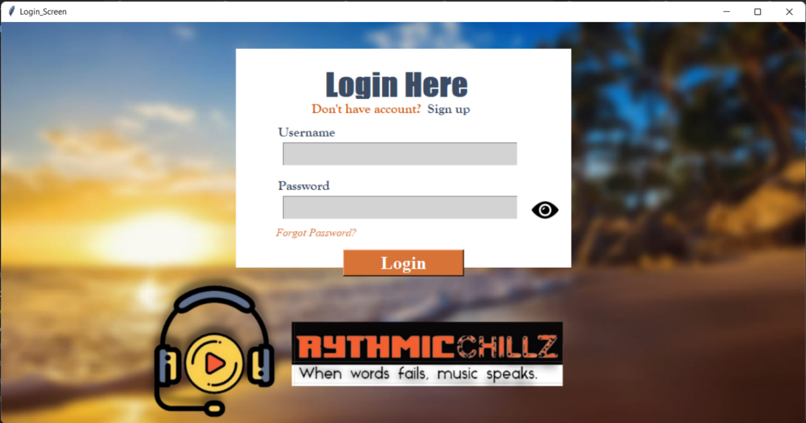

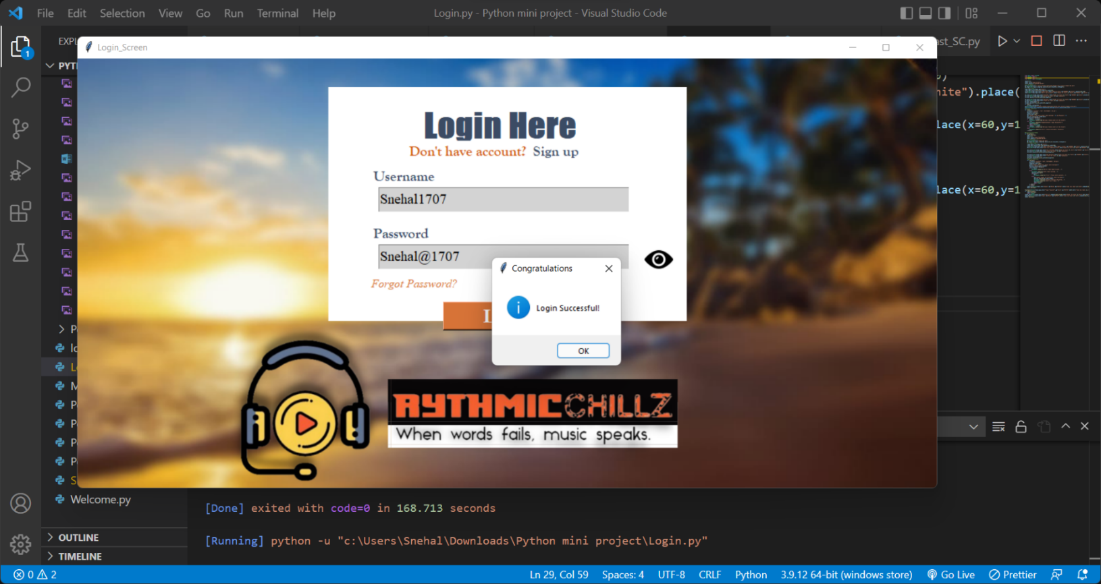

1. **Sign Up Page:**

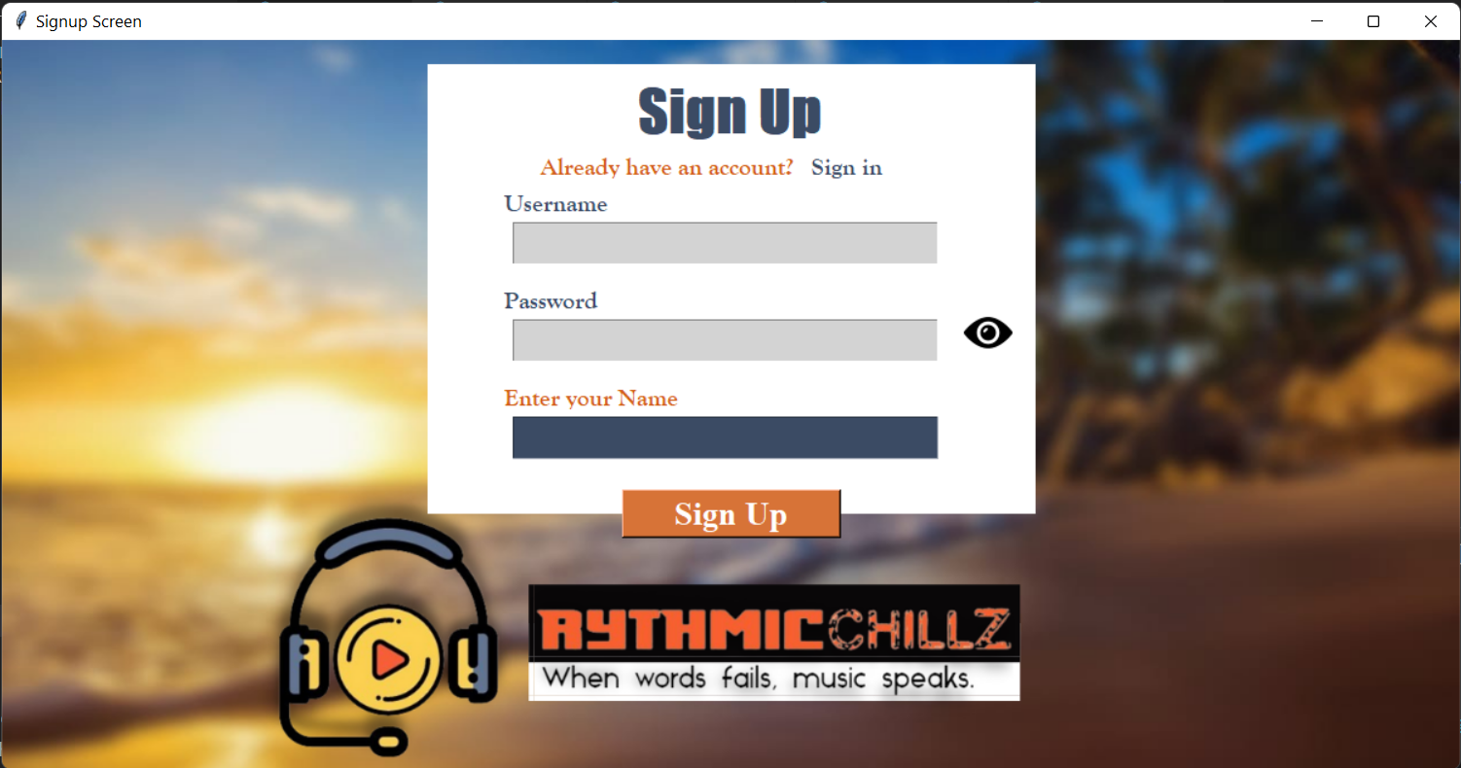

1. **Forgot Password Page:**

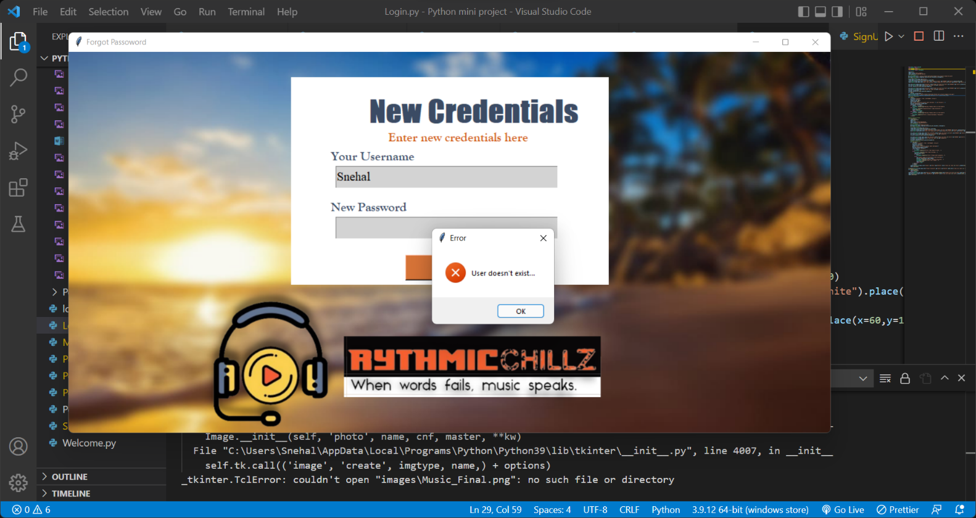

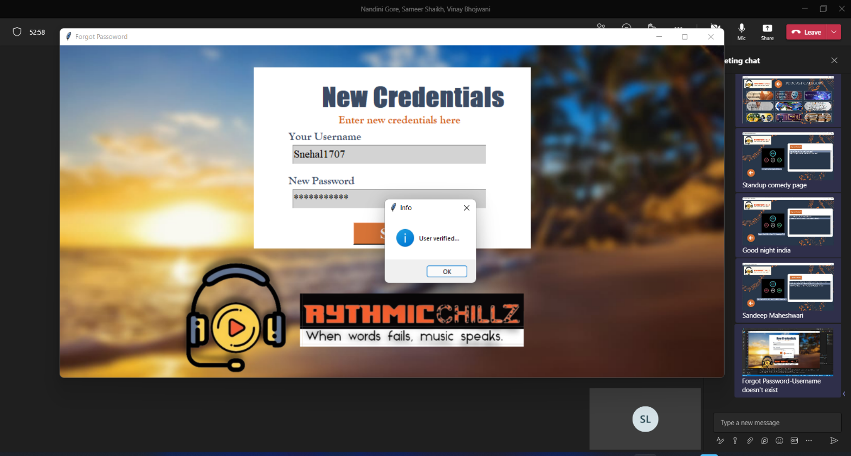

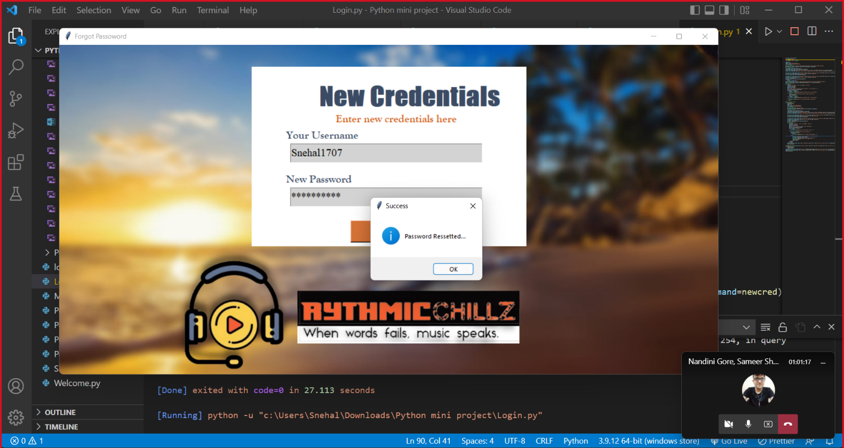

1. **Welcome Page:**

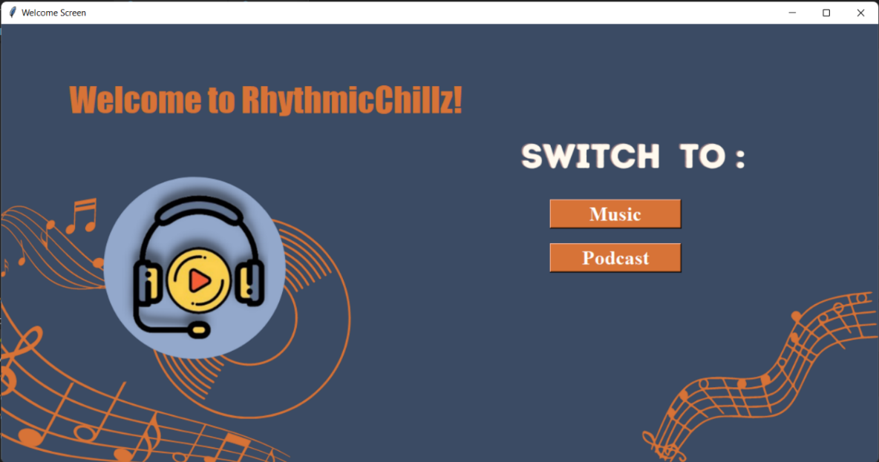

1. **Music:**

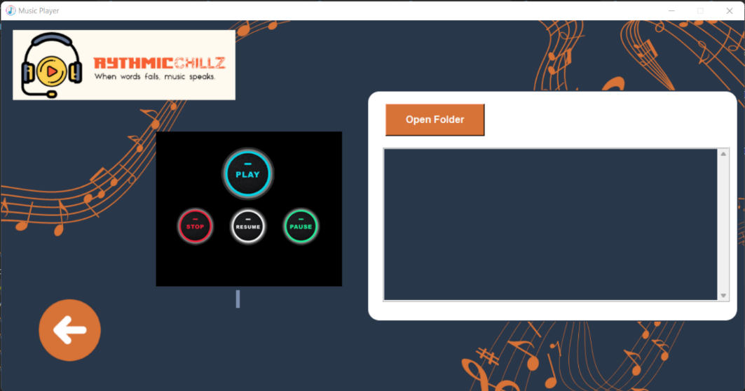

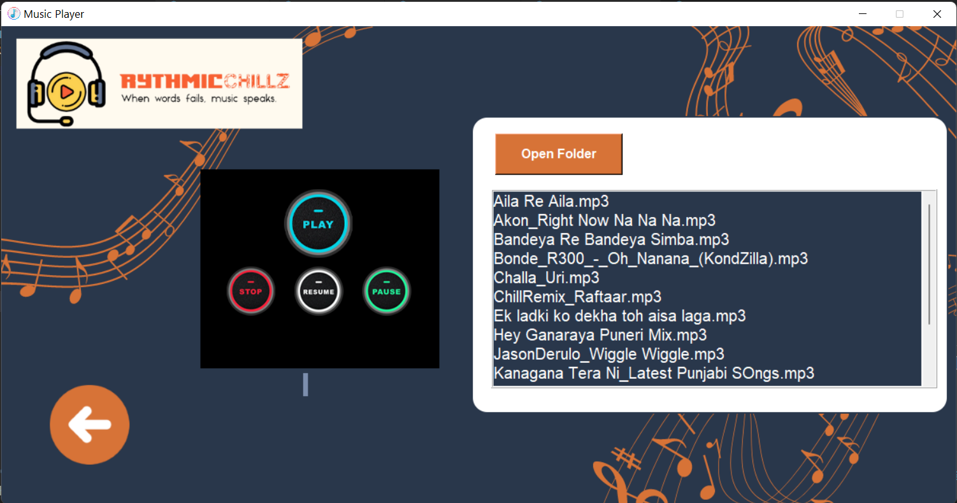

1. **Podcast’s Category Page:**

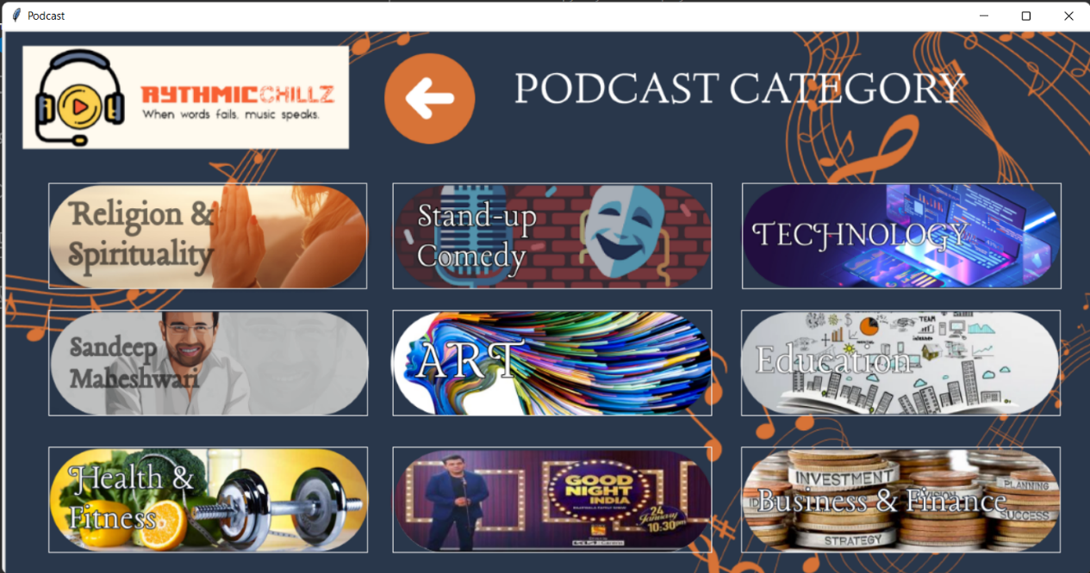

1. **Podcast: Good Night India: -**

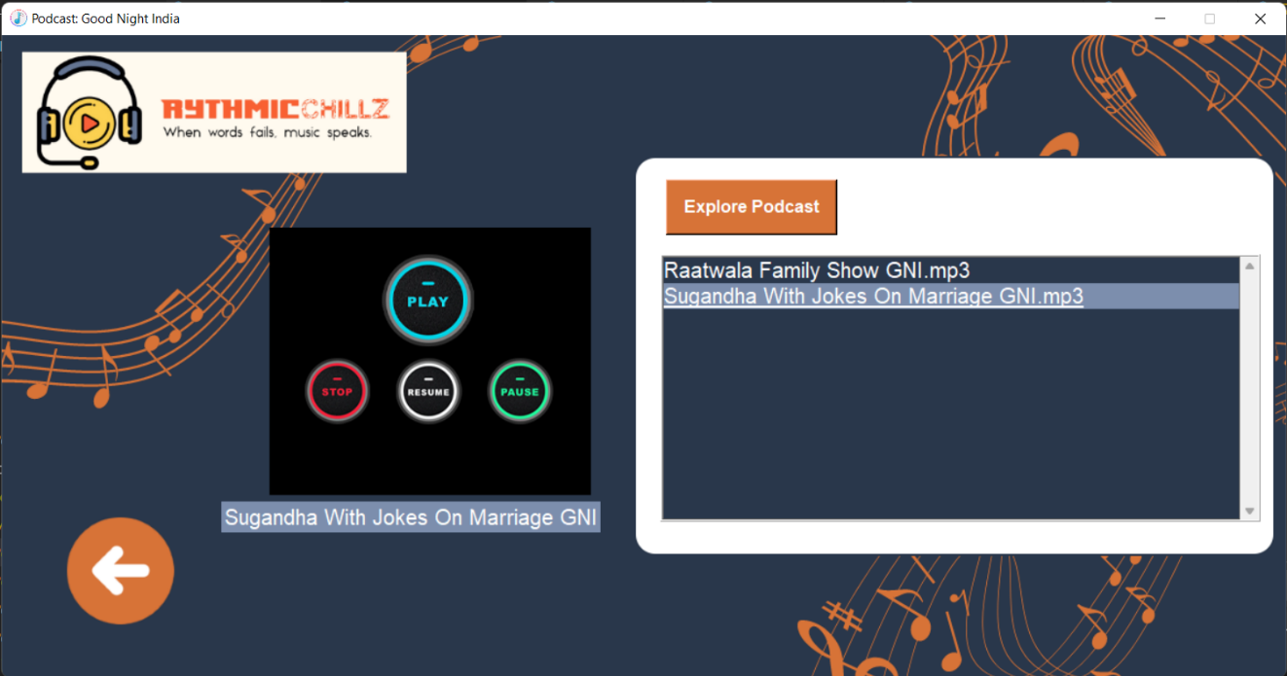

1. **Podcast: Sandeep Maheshwari: -**

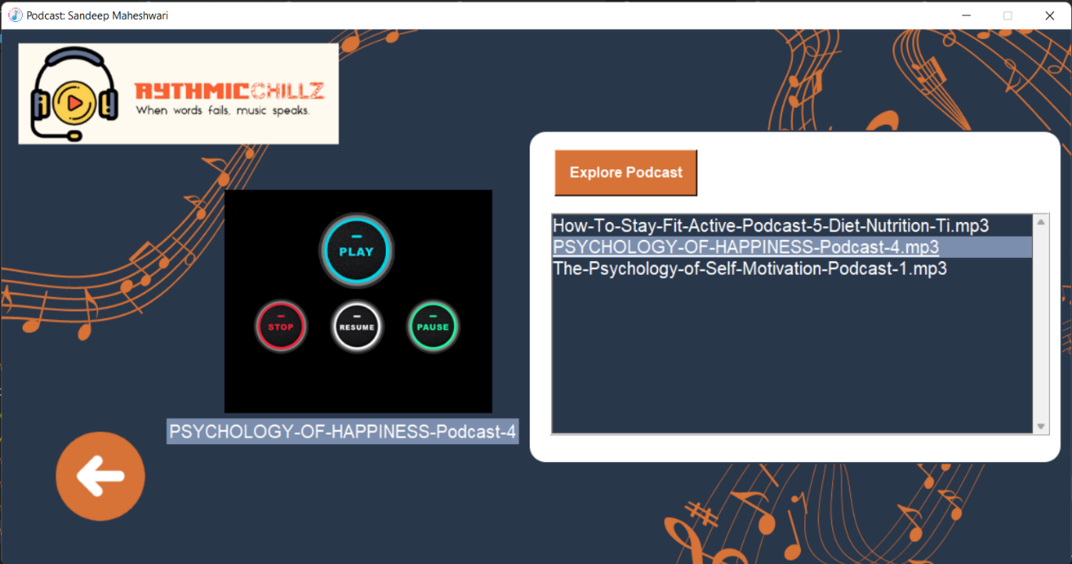

1. **Podcast: StandUp Comedy: -**

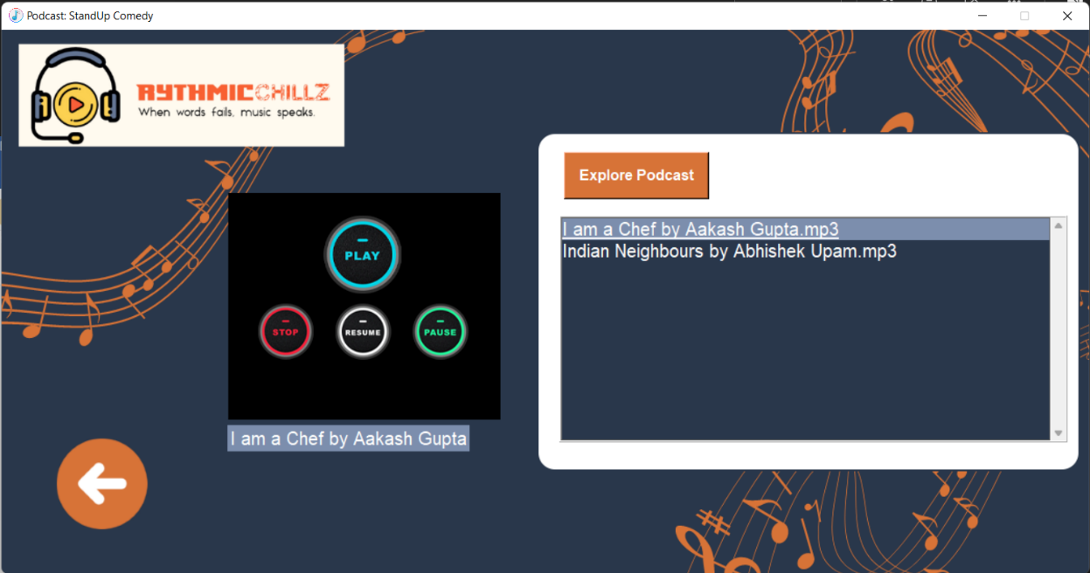

**References:**

1. YouTube
2. Stack Overflow
3. Codemy